**HOTEL BOOKING ANALYSIS**

**BUSINESS CHALLENGE**

Over the past few years, both City Hotel and Resort Hotel have experienced significant increases in cancellation rates. This has led to various complications for each establishment, such as decreased revenue and suboptimal utilization of hotel rooms. Therefore, the main objective for both hotels is to reduce cancellation rates, aiming to enhance revenue generation efficiency. Our aim is to provide business advice to tackle this issue effectively.

This report primarily focuses on analyzing hotel booking cancellations, along with other factors unrelated to their core business operations and annual revenue generation.

**RESEARCH QUESTIONS**

Which factors influence the cancellation of hotel reservations?

What strategies can be implemented to improve the handling of hotel reservation cancellations?

How can hotels be supported in formulating pricing strategies and promotional campaigns?

**HYPOTHESES**

Higher prices are likely to correlate with increased cancellation rates.

Resort hotel shows higher average daily rate compared to City hotel.

The predominant method for clients to make reservations is through offline travel agents.

**ANALYSIS & FINDINGS**

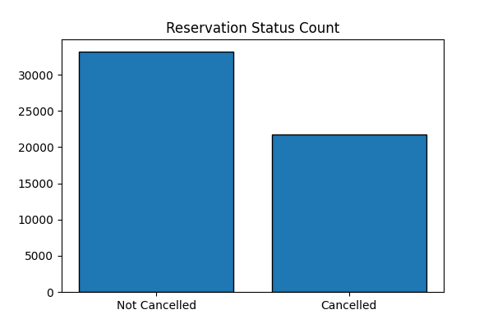

The provided bar graph illustrates the distribution of cancelled and non-cancelled reservations. It is apparent that a substantial portion of reservations remains unaffected by cancellations (61%). Nonetheless, the cancellation rate of 39% is notably high, signifying a considerable impact on the hotels' revenue.

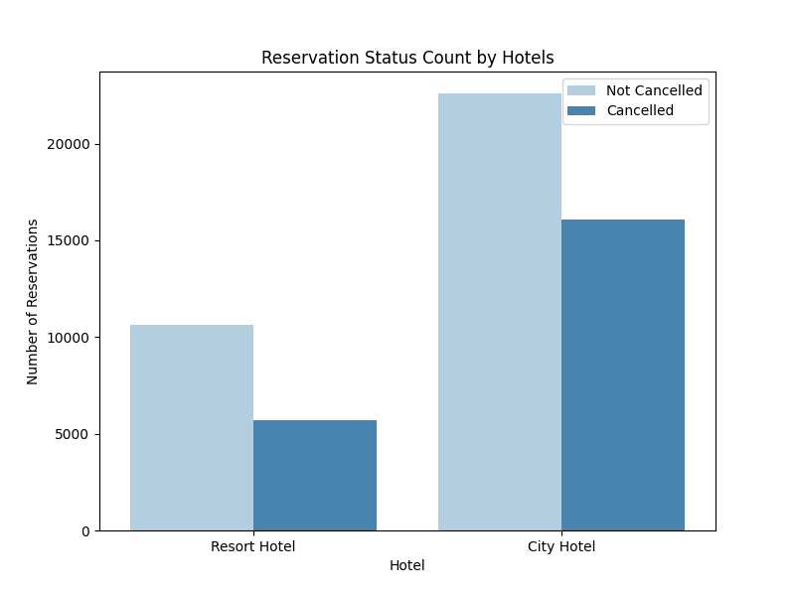

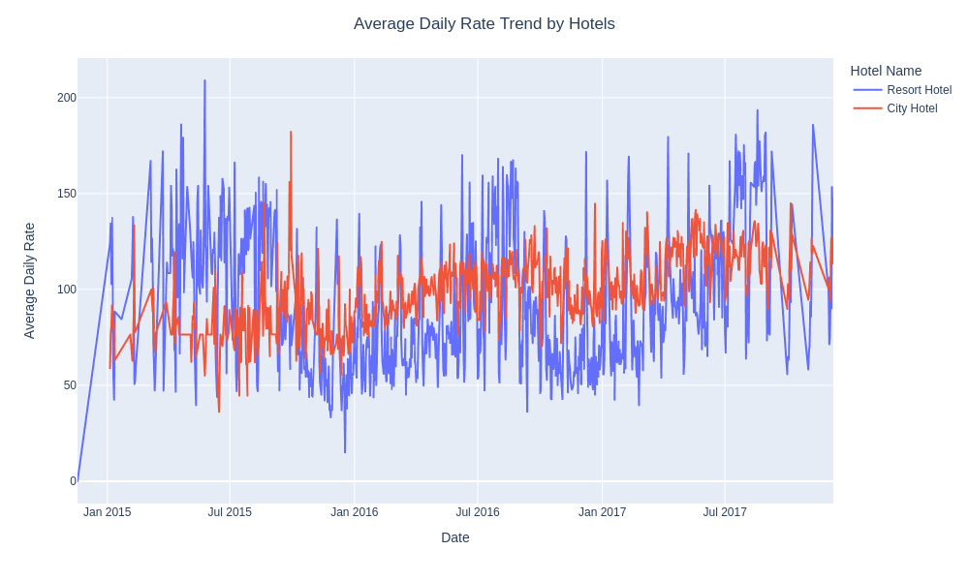When comparing resort hotels to city hotels, it appears that city hotels tend to have a greater volume of bookings. This discrepancy might be attributed to the possibility that resort hotels typically command higher prices than city hotels. However, despite this difference, city hotels have also experienced higher cancellation rates compared to resort hotels.

The line graph depicted above illustrates that, for the majority of days, the average daily rates of resort hotels surpass those of city hotels. The abrupt increases observed in the average daily rates 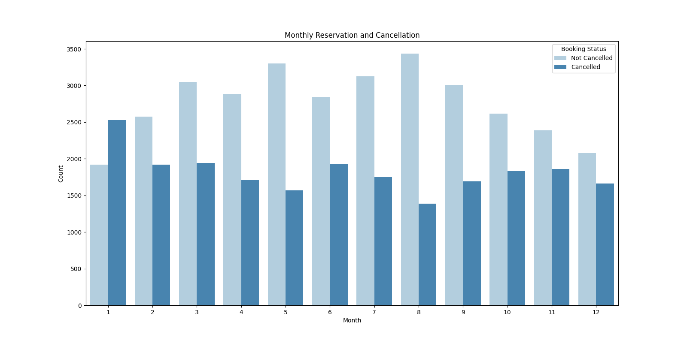for both types of hotels coincide with weekends and holidays.

I have created this grouped bar graph to examine the months with the highest and lowest reservation levels based on their status. It is evident that August has the highest number of confirmed reservations and the lowest number of cancellations, whereas January exhibits the highest number of cancellations.

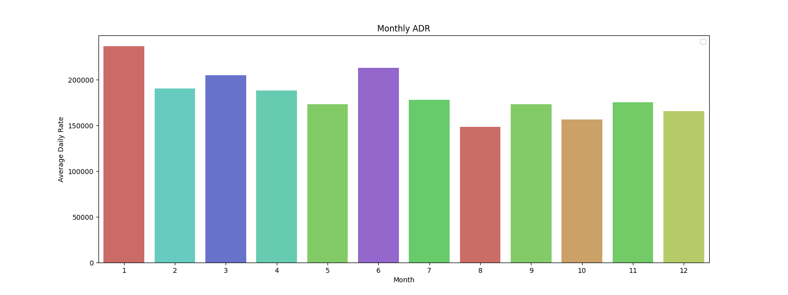

The bar graph above illustrates that cancellations occur most frequently when prices are at their highest and are least frequent when prices are at their lowest. Hence, the cost of accommodation directly influences the likelihood of cancellations.

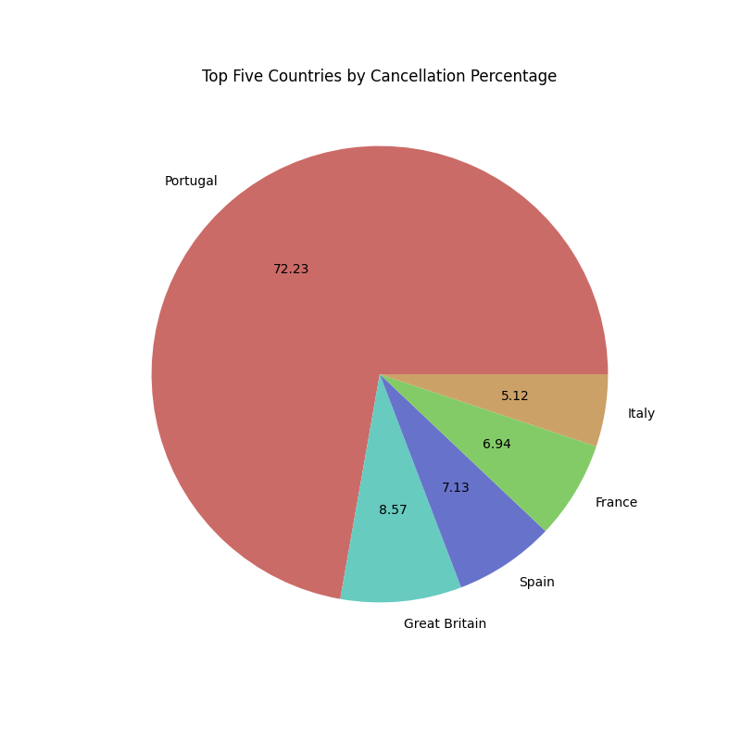

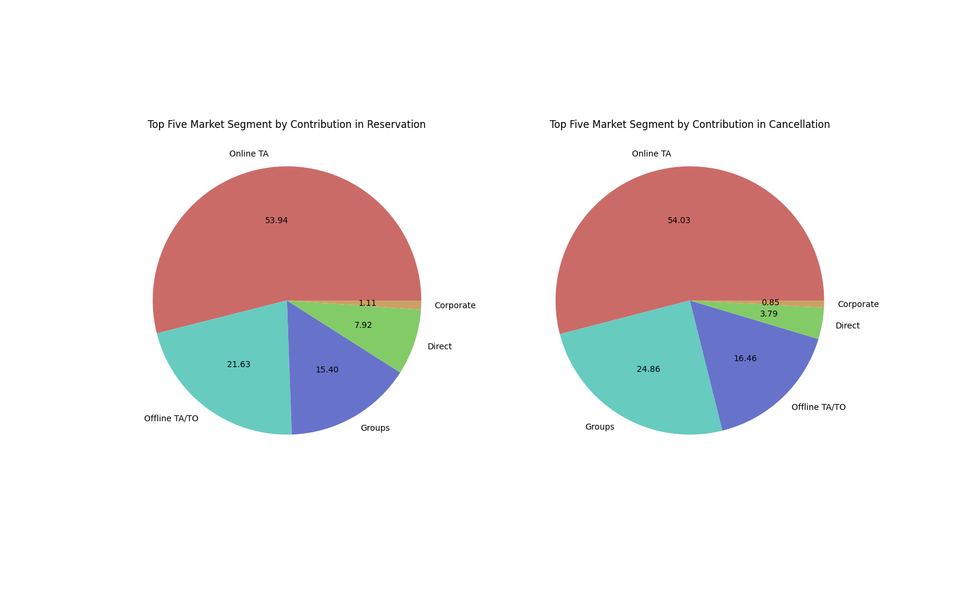Portugal ranks as the top country with the highest number of cancellations, followed by Great Britain, Spain, France, and Italy.

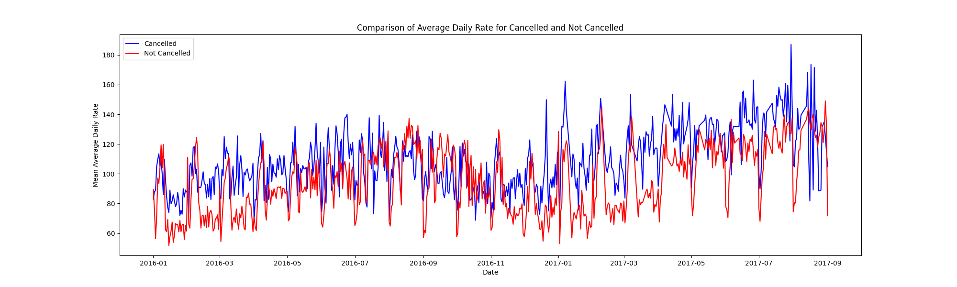The shared image presents two pie charts comparing the top five market segments in reservation and cancellation contributions. Key findings indicate that Online Travel Agencies (TA) hold a dominant position in both reservations (53.94%) and cancellations (54.03%). Groups also play a significant role in cancellations (24.86%). Offline TA/TO holds notable shares in both categories, while Direct and Corporate segments have minimal impact. Overall, the data underscores the importance of comprehending and managing Online TA behavior to optimize reservations and mitigate cancellations.

As depicted in the graph above, cancellations of reservations tend to occur when the average daily rate is higher compared to instances where reservations are not cancelled. This observation solidifies the preceding analysis, indicating a direct correlation between higher prices and increased cancellation rates.

**SUGESTIONS**

1. As prices increase, so do cancellation rates. To mitigate reservation cancellations, hotels could refine their pricing strategies by reducing rates for select locations and offering discounts to customers.

2. While raising prices during weekends and holidays may yield benefits, it's advisable to maintain pricing at reasonable levels.

3. In January, hotels can initiate marketing campaigns within a reasonable budget to attract more customers, subsequently decreasing cancellation rates and increasing revenue.

4. Enhancing service quality, particularly in Portugal, is another avenue for reducing cancellation rates.

5. Take advantage of Online Travel Agents’ strong influence, as they make up a big chunk of both reservations and cancellations. By understanding how they operate, hotels can make more bookings and reduce cancellations. Special offers can be offered to groups which will reduce their cancellation. Additionally, it's important to consider Offline Travel Agents for a complete strategy.